**Session 01 Discussion Questions**

# The Project Life Cycle

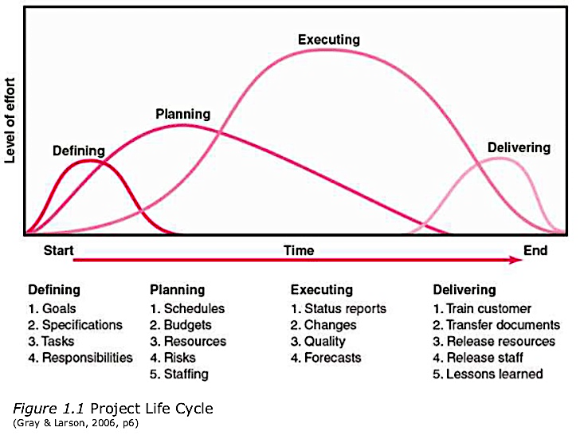

Which stage of the four stages of the project life cycle do you think is most critical for project success? Discuss and explain your choice.

# Shadowing a Project Manager

Meet Tom

Tom has been a project manager at ETW Nautical Supplies for about five years. Today, like most days, Tom arrives at his office an hour early. He spends the first 30 minutes reading his e-mails and catching up on voicemails. Then he saunters down to cafeteria where he gets his morning coffee and chats with his coworkers and reports as they filter in to get their own coffees. He gets delayed by Marge, a member of one of his core teams, who is excited to show him photos of her new grandson, Oliver. This means he gets back to his office a little later than planned. He spends about an hour sending e-mails and returning phone calls, before he takes a stroll through Cubicle Alley, as he calls it. He stops by each team member’s desk to check in. “What’s happening?” he queries each person. These ritual stops have become known at ETW as drive-bys. Just as he begins to prepare for a project meeting with his team on the crucial Sail2020 project, he gets an angry phone call from a vendor for Sail2020 complaining that the team is now asking for extra features that were not in the original specs and that adding those features will double the price of the parts. Tom tells him that he will find out what is going on and get back him. After slamming the phone down, Tom returns to Cubicle Alley and begins yelling, “What the heck is going on here? Why didn’t anyone tell me this earlier?” After spending 45 minutes getting to the bottom of the problem, Tom learns it is the client who is making these demands to the team. Tom stomps back to his office, and calls the client, who doesn’t answer. Now Tom is behind schedule getting his meeting organized, so he works through lunch to get the agenda for the Spinnaker2014 project finished. There’s no sense sending it out, as they will meet in 15 minutes at 1:30 p.m.

Tom arrives at the meeting room on time, but team members trickle in until 1:45 p.m. During this time, Marge pulls out the photos of Oliver and shows them to the team members present. They then pull out the photos of their kids and grandchildren to share. The meeting doesn’t get started until 1:50 p.m. At 2:14, Tom’s boss Mary Sue arrives. She apologizes for being late and explains why she is so busy. Everyone listens. Then, Tom summarizes what Mary Sue missed. The meeting gets back on track at 2:25 p.m., only to have two critical members of the team leave, explaining they have another meeting at 3 p.m. across the expansive ETW corporate campus. Mary Sue gets impatient, and wants a quick summary of just where the project is in terms of deadlines. She hears a summary of what the team has done. At 2:55 p.m., Mary Sue leaves, saying she wants an update on her desk by the end of business that day. The meeting breaks up shortly after 3 p.m. Tom announces he will send out a Doodle to find a time for the next meeting. When Tom returns to his office, he has an irate message from the client, who says he isn’t satisfied with the progress on the project. Tom immediately calls him and tries to explain that the added features the client wants are out of scope and will drive up the cost of the project. The client threatens to fire ETW and take his business elsewhere. Tom manages to arrange a meeting at the client’s office tomorrow morning. Hanging up the phone at about 4 p.m., Tom feels exhausted, so he shuts his office door, turns off the computer and turns down the ringer on his desk phone and cell phone and takes a 20-minute power nap. When his alarm awakens him, he begins writing that project update Mary Sue has asked for but has to make a couple of calls to the team to get some of the specific information she wants. It is shortly after 6 p.m. when Tom e-mails the update to Mary Sue. Victoria, another ETW project manager, stops by his office. She is in a crunch with a key project and needs to get more hours this week from the IT person she and Tom share. They work out a schedule, and Victoria leaves saying, “Thanks, Tom. I owe you one.” Tom answers a few critical e-mails and packs his briefcase for his meeting with the client tomorrow and leaves his office around 7 p.m.

**What do you think?**

* What did Tom do that you think are smart practices for a project manager?
* What might he have done better?
* How effective do you think Tom is as a project manager?
* If you were to make one recommendation to Tom, what would it be?

# How Does Organizational Culture Affect Project Management?

* How do you think your organizational culture influences projects in your organization, whether that organization is a corporation, a small business, a nonprofit, or a volunteer organization?
* What are the advantages of a smaller organization, less than 20 employees, when it comes to managing projects? What are the disadvantages?
* What are the advantages of a large organization, more than 200 employees, for managing projects? What are its disadvantages?

# Be as specific as possible. Use real world examples wherever possible.